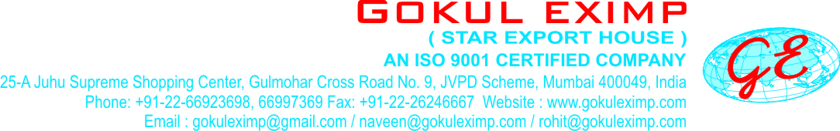
RECATIVE COLD DYES
Reactive Cold Dyes |  | FASTNESS PROPERTIES
 |  | Light | Washing | Perspiration | Hypochlorite | Dischargeability
Reactive Red M5B  Reactive Red - 2 |  | 4-5 | 4-5 | 3-4 | 1 | P
Reactive Red M8B  Reactive Red - 11 |  | 4-5 | 4-5 | 2 | 4 | P
Reactive Magenta MB  Reactive Violet - 13 |  | 4-5 | 5 | 4-5 | 1 | F
Reactive Orange M2R  Reactive Orange - 4 |  | 5 | 5 | 4 | 4 | P
Reactive Orange M2RJ |  | 3-4 | 4 | 4 | 4-5 | P
Reactive Gol. Yellow MR  Reactive Yellow - 44 |  | 5 | 4-5 | 4 | 1 | P
Reactive Yellow MR EX H/C  Reactive Yellow - 44 |  | 5 | 4-5 | 4 | 1 | P
Reactive Yellow M3R  Reactive Yellow - 36 |  | 6 | 5 | 4 | 2 | G
Reactive Yellow M4R  Reactive Orange - 14 |  | 5 | 4-5 | 4 | 1 | P
Reactive Yellow M8G  Reactive Yellow - 86 |  | 6 | 4-5 | 4-5 | 1 | G
Reactive Yellow M4G  Reactive Yellow - 22 |  | 6 | 4 | 5 | 1 | G
Reactive Yellow MGR  Reactive Yellow - 7 |  | 6 | 5 | 4-5 | 4-5 | P
Reactive Violet C4R  Reactive Violet - 12 |  | 4 | 3 | 4 | 1 | P
Reactive Violet C2R  Reactive Violet - 14 |  | 3-4 | 3 | 4 | 1 | P
Reactive Blue MR  Reactive Blue - 4 |  | 6 | 5 | 5 | 2 | P
Reactive Blue M2R  Reactive Blue - 81 |  | 6 | 5 | 4-5 | 1 | P
Reactive Blue M2R H/C  Reactive Blue - 81 |  | 6 | 5 | 4-5 | 1 | P
Reactive Navy Blue M3R  Reactive Blue - 9 |  | 5 | 4-5 | 3 | 3 | P
Reactive Blue M4GD H/C  Reactive Blue - 168 |  | 6 | 5 | 3-4 | 2 | P
Reactive Tur. Blue MGN  Reactive Blue - 140 |  | 6 | 4 | 4 | 2-3 | P
Reactive Tur. Blue Ha5G  Reactive Blue - 71 |  | 6 | 3-4 | 4-5 | 3-4 | P

