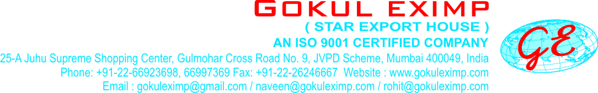

REACTIVE DYES VINYL SULPHONE BASE
Reactive Vinyl Sulphone Base Dye |  | FASTNESS PROPERTIES
 |  | Light | Washing | Perspiration | Hypochlorite | Dischargeability
Reactive Red 4B  Reactive Red - 24 |  | 6 | 3-4 | 5 | 1 | G
Reactive Red 5B  Reactive Red - 35 |  | 6 | 3-4 | 5 | 1 | G
Reactive Red C2G  Reactive Red - 106 |  | 4 | 4-5 | 5 | 1 | G
Reactive Red RB  Reactive Red - 198 |  | 5-6 | 4-5 | 4 | 1 | F
Reactive Orange 3R  Reactive Orange - 16 |  | 5-6 | 5 | 5 | 1 | G
Reactive Orange 2R  Reactive Orange - 7 |  | 4-5 | 4-5 | 5 | 1-2 | G
Reactive G. Yellow R  Reactive Yellow - 20 |  | 5 | 4-5 | 5 | 1 | G
Reactive Yellow FG  Reactive Yellow 42 |  | 5 | 5 | 5 | 1 | G
Reactive Yellow GR  Reactive Yellow -15 |  | 6 | 5 | 5 | 1 | G
Reactive Yellow RTN  Reactive Yellow - 24 |  | 6-7 | 4 | 4 | 2 | F
Reactive G. Yellow RNL  Reactive G. Yellow - 107 |  | 5 | 4-5 | 4-5 | 1 | G
Reactive Yellow R  Reactive Yellow - 77 |  | 4-5 | 5 | 5 | 1 | G
Reactive Yellow GL  Reactive Yellow - 37 |  | 6-7 | 4-5 | 5 | 1 | G
Reactive Black B  Reactive Black -5 |  | 5 | 4-5 | 5 | 1 | G
Reactive Black RL  Reactive Black - 31 |  | 7 | 4-5 | 5 | 3-4 | F
Reactive Violet 5R  Reactive Violet - 5 |  | 6-7 | 4 | 3-4 | 5 | P
Reactive Tur. Blue G.  Reactive Blue-21 |  | 6 | 4-5 | 5 | 3-4 | P
Reactive Tur. Blue H2GP |  | 6 | 4 | 5 | 3-4 | P
Reactive Blue 3R  Reactive Blue - 28 |  | 7 | 4 | 5 | 3-4 | G
Reactive Blue R  Reactive Blue - 19 |  | 6-7 | 4-5 | 4-5 | 3-4 | F
Reactive Blue RGB  Reactive Blue - 250 |  | 4-5 | 3-4 | 4 | 1 | G
Reactive Blue BB  Reactive Blue - 220 |  | 6-7 | 4 | 5 | 1 | G
Reactive Dark Blue HR  Reactive Blue - 89 |  | 5-6 | 3-4 | 5 | 1 | F
Reactive Navy Blue GG  Reactive Blue - 203 |  | 4-5 | 3-4 | 5 | 1 | F
Reactive Navy Blue GG |  | - | - | - | - | -
Reactive Brown GR  Reactive Brown - 18 |  | 6 | 4-5 | 4 | 1 | G
Reactive Black WNN |  | 5 | 4-5 | 5 | 1 | G

