BASIC DYES
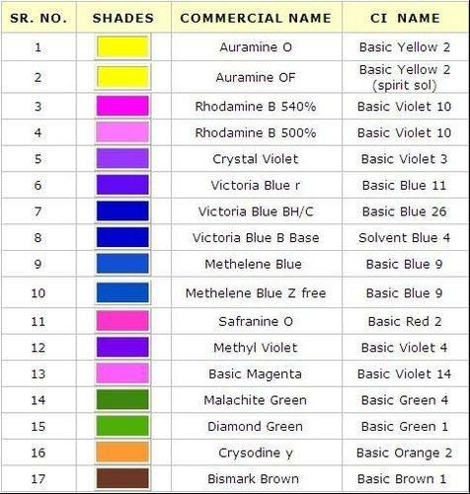

NO. | PRODUCT NAME | C.I. NAME | C.I. NO | CAS NO.
1 | MYTHYL VOLIET LIQUID 50% | BASIC VOLIET 1 | 42535 | 84434-47-9
2 | MYTHYL VOLIET | BASIC VOLIET 1 | 42535 | 83968-28-9
3 | CRYSTAL VOLIET LIQUID 50% | BASIC VOLIET 3 | 42555 | 67939-65-5
4 | CRYSTAL VOLIET | BASIC VOLIET 3 | 42555 | 548-62-9
5 | ETHYL VIOLET LIQUID 50% | BASIC VOLIET 4 | 42600
6 | ETHYL VIOLET | BASIC VOLIET 4 | 42600 | 2390-59-2
7 | RODAMINE B LIQUID | BASIC VOLIET 10 | 45170 | 64381-99-3
8 | RODAMINE B | BASIC VOLIET 10 | 45170 | 81-88-9
9 | MAGENTA | BASIC VOLIET 14 | 42510 | 62-99-5
10 | BASIC VIOLET 16 LIQUID | BASIC VIOLET 16 | 48013 | 64364-30-1
11 | METHYLENE BLUE 2B | BASIC BLUE 9 | 52015 | 61-73-4
12 | VICTORIA BLUE LIQUID 40% | BASIC BLUE 26 | 44045 | 8303-79-6
13 | VICTORIA BLUE | BASIC BLUE 26 | 44045 | 2580-56-5
14 | BIRRLANT GREEN 50% | BASIC GREEN 1 | 42040 | 76994-37-1
15 | BIRRLANT GREEN | BASIC GREEN 1 | 42040 | 633-03-4
16 | MALACHITE GREEN 50% | BASIC GREEN 4 | 42000 | 41272-40-6
17 | CHRYSODINE Y LIQIUID 35% | BASIC ORANGE 2 | 11270 | 79234-33-6
18 | CHRYSODINE Y | BASIC ORANGE 2 | 11270 | 532-82-1
19 | AUROMINE - O | BASIC YELLOW 2 | 41000 | 2465-27-2
20 | AUROMINE – O OF SPRINT SOLUBLE | BASIC YELLOW 2 | 41000
21 | ETHYL AURAMINE | BASIC YELLOW 37 | 41001 | 2465-27-2
22 | BASIC YELLOW 96 LOIUID | BASIC YELLOW 96 |  | 78181-99-4
23 | BISMARK BROWN G LIQUID 50& | BASIC BROWN 1 | 21000 | 10114-58-6
24 | BASIC RED 12 LIQUID | BASCI RED 12 | 48070 | 6320-14-5
25 | BASIC RED 14 LIQUID | BASIC RED 14 |  | 12217-48-0
26 | BASCIS RED 49 LIQUID | BASIC RED 49 |  | 12270-23-4

